Rules
The Rules of the Championships will be as per the Little League Baseball 2026 Rulebook. More specifically the Tournament Rules under Section Titles - CONDITIONS OF TOURNAMENT PLAY and TOURNAMENT PLAYING RULES. Where the Tournament Rules {referenced within as “TR”} are silent on an issue the Regular Season rules apply {referenced within as “PR”}. Where those rules are silent on a subject the Rules of Baseball will be applied. Where there is a conflict between the Little League Tournament Rules and this handbook, the latter shall be applied.

NOTE - Game Information
- Game duration is seven (7) innings. There shall be no time limit on games and all games shall play to a result. EXCEPTION: Consolation games may have a maximum time limit enforced and shall be communicated to the teams and officials by the Tournament Director.
- There are no run limits per inning.
- Sixty (60) seconds will be allowed for innings change over.
- If at the end of a regulation game (five innings) one team has a lead of ten (10) runs or more OR a lead of fifteen runs (15) after four (4) completed innings, the manager of the team with the least runs shall concede victory to the opponent.
- SECTION III – TIEBREAKER PROCEDURES will be used to seed teams after pool play if necessary.
- Protests involving playing rules not resolved before the next pitch or play shall not be considered – a tournament official will be available at all games to assist with protest resolution.

NOTE - Determining Home / Away Teams
- All fields are considered neutral – the home team shall be determined by the toss of a coin with the winner having the choice. Managers are to arrange between themselves at least 25 minutes before the scheduled start time of the game.

NOTE - Mandatory Play
For Senior League Division, there are no specific Mandatory Play requirements per game, however, Managers are expected to ensure all rostered players are utilised fairly throughout the tournament.

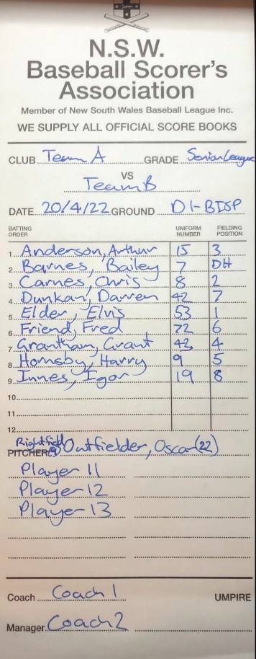
NOTE – Designated Hitter Rule
- The DH can be for any player in the line-up, not just the pitcher.
- The Example on the right can be used as a guide for how to designate who the DH is hitting for.
- Noting that Oscar Outfielder is the Right Fielder (number 22) who does not bat as Bailey Barnes is the DH for the Right Field Position.

NOTE - Pitching
Pitching rules, including limits and applicable rest days, are included in {TR4}.
- Maximum Daily Pitching limits are included in {TR 4 (d)}.
- Pitcher’s Rest requirements are included in {TR 4 (e)}.
- The pitchers pitch count for the days rest threshold is determined by the first pitch thrown to the batter.
- No Player is permitted to pitch in three consecutive days {TR4(e)Note}
- A pitcher remaining in the game defensively, but moving to a different position, can return as a pitcher anytime in the remainder of the game, but only once per game. {TR4(c)}
- If a pitcher is kept to a threshold of 30 pitches (can finish the batter) in the first game, they may pitch in a second game on the same day. {TR4(f)}
- Pitchers are permitted to pitch up to, but not exceed, eight (8) preparatory pitches at the commencement of an innings or assignment. {PR8.03}
- Balks shall be applied in this Division.
- Managers or coaches are not permitted to warm up a pitcher at home plate or in the bullpen or elsewhere at any time. They may stand to observer a pitcher during a warm-up in the bullpen.

NOTE - Intentional Walk

The Defensive Manager may elect to “Intentionally Walk” a batter at any point during an at-bat by requesting, and being granted, “time” by the umpire before notifying the plate umpire of the defense’s intent to walk the batter.

NOTE 2: The ball is dead, and no other runners may advance unless forced by the batter’s award. The appropriate number of “balls” needed based on the count on the batter at the time of the manager’s request to complete the Intentional Walk pitches will be added to the pitch count.

A player may only be intentionally walked once per game but may achieve base-on-balls through four pitched balls in other at-bats.

NOTE - Pitching and Catching in One Day
- Players can occupy the position of pitcher and catcher on the same day as long as the imposed limits are observed.
- Any pitcher, who delivers 41 or more pitches cannot play the position of catcher for the remainder of that day (the pitcher can finish pitching to the batter in the box when the threshold limit is reached but cannot start a new batter).
- Any player, who has played the position of catcher ‘IN’ 4 or more innings in a game, is not eligible to pitch on that calendar day. A player who has played the position of catcher then pitched may return as a catcher on the same day subject to the restriction in {TR4 (a) EXCEPTION}

NOTE - Visits
Visits – A Manager or Coach may come out once in one inning to visit with the pitcher, the second time out the player must be removed as a pitcher. The Manager or Coach may come out two times in a game to visit with the pitcher, but the third time out the player must be removed as a pitcher. {PR8.06(a)}

NOTE - Collision Rules

In NSW Junior Baseball we have an anti-collision rule;
- The Championships will be played with the interpretation that rule 7.08 (a)(3) the runner is out if “… the runner does not slide or attempt to get around a fielder who has the ball and is waiting to make the tag…” will align with our anti-collision rules – if a play is imminent then the runner must avoid a collision.
- Note: there is no must slide rule. The act of sliding, in a legal manner, is considered to be a means to avoid a collision.

NOTE - Protective Equipment
- Base Coaches must wear approved helmets (skull caps acceptable for adults). Junior base coaches must wear batting helmets.
- Catchers must wear hockey-style catchers mask (skull cap and mask style are not acceptable) with dangling throat guards during infield/outfield practice, pitcher warm-up and games {TR 1.17}.

NOTE - Substitutions / Special Pinch Runner

- Any player starting the game who has been removed for a substitute may re-enter the game once, in the same position in the batting order.

- Special Pinch Runner (SPR) may only be used twice in a game and only once per inning per team. The same player may not be substituted for an SPR more than once. There is no increase in the number of SPRs allowed per game if the game enters extra innings to obtain a result.

Dug-out Designation
The team listed first on the draw will occupy the third-base dugout, the team listed second will occupy the first-base dugout unless a team is in situ due to a prior game.
Teams are permitted to have three eligible coaches in the dugout regardless of the tournament team roster size.
Team EO's are allowed to enter the team dugout during Game times only to address player welfare and injury issues but otherwise are to remain outside of the dugout. An exception to this is where the EO is also listed as a coach and forms part of the eligible number of coaches on a team’s coaching staff.
The allocation of teams to the batting cages will be sent to the Coaches and EO's at the end of the previous day by the Tournament Director.

Infield/Outfield
Infield/Outfield can only be undertaken if there no preceding game, or the preceding game finishes more than 30 minutes before the scheduled game commencement and the Ground Crew have vacated the field 20mins before game time
If teams wish to complete an Infield/Outfield as part of the pre-game the following protocols will be observed;
At 20 minutes before the scheduled start time, the home team will take the field for infield/outfield (7 Minutes available)
12 minutes before the scheduled start time the away team will take the field for infield/outfield (7 Minutes available)

Scheduling of Games
Where possible the games will be played as per the published schedule.
Should it be necessary to move games between diamonds or alter scheduled start times the Tournament Director will advise the affected teams as soon as possible with confirmation of the change due to weather, extended games, light etc

Minimum Time Between Games

Should game durations extend beyond the times allowed for in the draw, the game start time will be adjusted and the following minimum times between games will apply:

Where the following game is to be played between two teams that have not played in the preceding timeslot – the following game will commence 20 minutes after the completion of the preceding game.

Where the following game is to be played between one or more teams that have played in the preceding timeslot - the following game will commence 30 minutes after the completion of the preceding game.

Closing Ceremony
There will be a brief presentation after the Senior League Tournament Games.
Teams present are welcome to join and the Championship Banner will be awarded to the winner.

Medical Support
Medics Australia will be on site for the Championships for all players and spectators. They will be located in the main amenities building. Medics will provide pre-game strapping if players supply their own tape.

VENUE

Blacktown International Sports Park, Eastern Rd, Rooty Hill NSW 2766

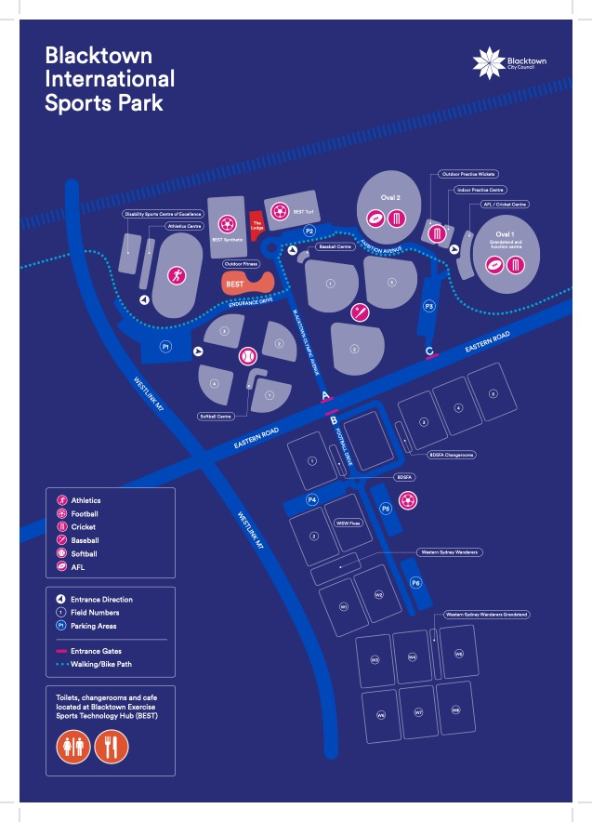

FACILITIES

Enclosed Playing Diamonds with covered dug outs

PARKING
- Parking is permitted in all parking areas except marked car parks in P2 that are reserved for BNSW Tournament staff and officials.
- Baseballs may enter the parking area; parking is at its own risk. Car’s parking on grassed areas or not in designated parking spaces may be fined by council inspector.

There are NO dogs allowed under any circumstance at BISP, and failure to comply may result in a heavy fine and removal from the ground.

2026 TEAM STAFF LIST

TEAM NAME | MANAGER | EO
CRONULLA BLUE | PETER WORBOYS | JASON TURNER
CRONULLA BLACK | NATHAN FUZ | PAUL MUIR
RYDE BLACK | MATT MINARD | MATT KELMAN
RYDE RED | MATT O’NEILL | KERRI TSUI
HILLS RED | JARRAD SALMON | MICHAEL SAWYER
HILLS BLUE | BRETT LENNOX | JAMES KIRBY
MACARTHUR COLTS | ADAM FORBES | REBECCA FORBES
MANLY | OWEN HARRIS | LUKE MALLAM
GW WARRIORS | PAUL RIDDLE | BRENDAN DERRICK
FAR NORTH COAST | PAUL SIMES | NATALIE SIMES
HUNTER COAST | JOSHUA VOIGT | ASHLEIGH HOKIN

TOURNAMENT OFFICIALS AND STAFF

TOURNAMENT DIRECTOR | MATT CARTER | 0400 993 116
COLMED GROUP
UMPIRES COORDINATOR | JERRY COBB | 0408 490 917
SCORERS COORDINATOR | JANINE HUNT | 0412 250 052

General but Important Information

- Championships balls will be supplied by Baseball NSW to each game.
- Each team must have a scorer. An official results sheet will be provided for each game – this will be completed by the home team scorer as the official scorer for the game.
- Only bats that meet the BNSW Bat regulations for Senior League State Championships, may be used in the tournament.
- All players should be well hydrated. Water is the preferred method of hydration of players in this age group.
- Supporters may wish to bring additional shelter for diamond side. Shaded tent areas will be provided in certain areas of the facility.
- BNSW facilities are non-smoking venues.

Parents and supporters are not permitted in or adjacent to the dugouts or on to diamonds to take photographs.
- Parents and supporters are not permitted to ask questions of the scorers or umpires of each game.

Baseball NSW is pleased to welcome all Charter teams to the Championships and wishes all teams the best of luck.

We also take the time to remind all Managers, Coaches, Players and Supporters of the Little League ethos.

Character Courage Loyalty

